**Features Missing from Odoo Community**

**Comprehensive Feature Listing for Odoo14**

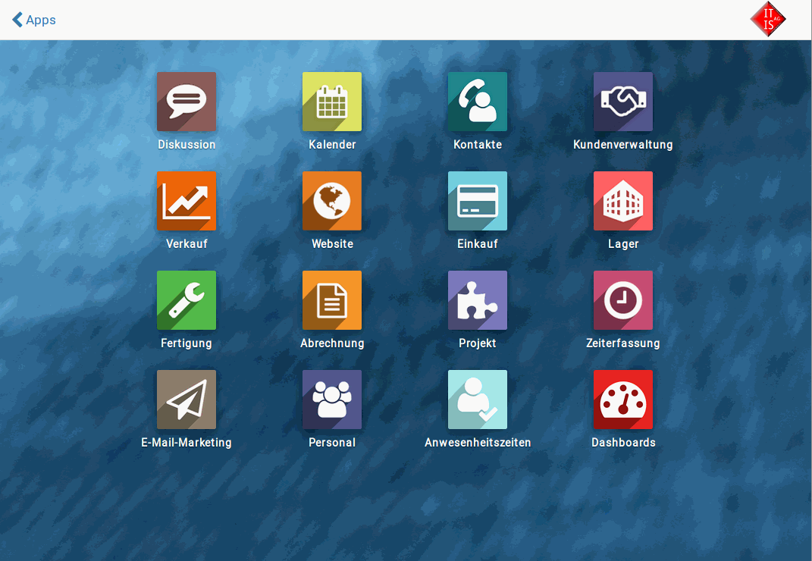

*Pic Source: Odoo Enhanced Community*

In 2021, Odoo came out with the stable Odoo14 version. It is currently the latest version of the widely used open-source ERP software that we know and love. But is a long and extensive process of collating the features of previous versions, managing changes, updates and commits to the [OCA](https://odoo-community.org/) ie. Odoo Community Association. Another common thing that happens is that Odoo can decide to move some functionalities exclusively to the enterprise edition and monetise their use. Therefore, there are a couple of features that are missing from the Odoo Community free version of the open-source we commonly refer to. In this article, we would discuss those features that are no longer in the free version.

The OCA is a nonprofit organization that promotes the use of Odoo and encourages the collaborative development of Odoo through the combined inputs of developers all around the world. In their [Github repository](https://github.com/OCA), we can easily see all the tools and plugins that are made available for public use. We can try integrations based on their compatibility, from the huge suite of features that Odoo offers. But not all things come for free! And that is why as a smart business, Odoo sometimes shifts features to the Enterprise or paid-for version. Today we focus on the features that were removed from Odoo13 and Odoo14 and are now in the fancier repo. The good thing is that we could still clone the Enterprise code and continue development in our machines, but when we need to use that software or over cloud services, we have to licence it from Odoo.

### 

### Features Removed from the Community Editions

We are sad to see the following features go from the Community Edition:

* HR Payroll is now exclusively in the Enterprise Edition. [source](https://www.odoo.com/forum/help-1/odoo-13-features-and-odoo-14-expected-features-148369)
* Payroll only in Enterprise Edition and no more in Community.
* Technical features are visible only by activating developer mode. Hidden otherwise. [Source](https://www.odoo.com/forum/help-1/technical-features-option-missing-on-users-form-94384)

### Features Exclusively in Enterprise Edition

In the table below, we concisely list all the features that are only available in the Enterprise version of Odoo:

| **Usage** | **Features missing from Community Edition** |
| --- | --- |
| Productivity | * IoT * Digital Phone (VoIP) Integration * Approvals |
| Services | * Field Service * Helpdesk * Planning * Appointments * Timesheets   + Grid view, timer, reminders, timesheet validation   + Awesome Timesheet (Mobile App) |
| * Customisation | * Odoo Studio |
| Marketing | * Marketing Automation * Email Marketing   + Mailing Templates * Social Marketing |
| Human Resources | * Referrals * Appraisals * Employees   + Departmental Dashboards |
| Manufacturing (MRP) | * Quality * PLM * Manufacturing   + Workcenter, Control Panel, Scheduling * Inventory   + Barcode |
| Sales | * Amazon Connector * Rental * Subscriptions * Point of Sale   + Loyalty Programs and Gift Cards |
| Finance | * ​​Accounting   + Comprehensive Accounting: General Ledger, Bank Statement Reconciliation, Analytic Accounting, Vendor Bill OCR, Budgets, Check Writing, Consolidation,Localizations, Reports * Invoice   + AI powered invoice automation   + Payments * Payroll   + Expense Digitalization (OCR)   + Reimbursement in Payslip * Documents   + Spreadsheet * Sign |
| User Interface | * Mobile: Android and iOS |
| General Features | * Unlimited Functional support * Version Upgrades * Hosting |

Also to comprehensively assess the versions, we list below all the features that were added to the Community edition as well. Thanks for being so nice, Odoo!

### Features Now in the Community Edition:

* Website Form Builder was added
* Sales Coupon
* Promotion module
* List View changes like mass editing in the list view, new button in the group by
* Leave renamed to Timeoff
* Smart buttons for opening Groups, Access Control List and Record Rules
* Kanban View New Search Panel

Odoo published their official Odoo14 [release notes](https://www.odoo.com/odoo-14-release-notes) for all the updates of the features that were added. The only caveat is that it is not the easiest to distinguish between the Community and Enterprise features. We would soon come out with a comparative article for Odoo15 as well, which is almost here for all. Right now, since most of us are using the stable version, we focussed on these features. If you are already in the future working on Odoo15, we salute you and you can find our detailed annual Odoo update article [here](https://www.bloopark.de/blog/unser-blog-1/post/odoo-15-was-bringt-uns-die-zukunft-485).

A trademark of being an open-source community is that we grow stronger together. Since the financial accounting feature was hidden for a lot of users, the [Odoo Enhanced Community](https://odoo-partner.org/get-enhanced) created a new version for professional ERP which is free to download with just signup.

This article was a quick round-up of the new and improved features, but also the missing features in Odoo14. We at Bloopark work with all your software needs from Migration, to development to support. So get in touch today for a quotation or more information. Thank you for reading!

References:

<https://www.cybrosys.com/blog/odoo-13-features>

<https://www.odoo.com/forum/help-1/odoo-13-features-and-odoo-14-expected-features-148369>

<https://www.odoo.com/page/editions>